Network categories => ranges
Pan (Personal area network) => less than 10 metres (Bluetooth devices)
Lan (Local area network) => home , small office (up to 1 kilometer)
Can => (Campus area network ) => upto 5 km
Man (Metropolitan area network ) => 5 to 50 km (local tv channel)
Wan (wide area network ) => the global (internet)

Networking communication methods
Data transmission methods => direction flow ( simplex, half-duplex, full-duplex)
Simplex => one way communication (cable tv wires)
Half-duplex => two way communication but not at same time (walkie-talkie)
Full-duplex => Data can travel in both directions simultaneously (calling voice)

Media access methods (Traffic rule)
CSMA/CD (wired) (Carrier Sense Multiple Access with collision detection)
Devices listen to the wire, if it’s quiet , they send data

CSMA/CA (wireless) (Carrier sense multiple access with collision avoidance)

Token passing => legacy method , a device can only transmit data if it is currently holding the token

Signalling methods
Baseband => entire bandwidth of the cable is used to transmit a single digital signal
Broadband => bandwidth is split up into multiple, distinct frequency

Network media and hardware
Bounded network media (Guided media ) (wired)
Twisted Pair cable (Ethernet) => it has inside copper wires are twisted around each other in pairs
Coaxial cable => central copper core surrounded by heavy insulation and a metal shield
Fiber optic cable => uses hair-thin strands of glass or plastic to transmit , light pulses rather than electricity
EMI => electrical interference

Unbounded Network media (unguided media) (wireless)

Radio waves => (wifi, Bluetooth) => can penetrate walls and travel in all directions from the source
Microwaves (Cell towers) => travels in straight line
Infrared => very short-range and requires strict line of sight , cannot penetrate

Network connectivity ( hardware)
Hub => (loudspeaker)
Switch => uses mac address
Router => router connects different networks (Ip address )

Network implementations
Ethernet Networks (wired) -> RJ45 Connector
Speed & Reliability
Full duplex
Security

Wireless Networks (Wireless) ->wireless Access point
Mobility
Security -> WP3
Frequencey – 2.4Ghz, 5 Ghz
Media access -> CSMA/CA (Collison avoidance )

Network Models
OSI model -> Open Systems Interconnection
7 Layers
Application
Presentation
Session
Transport
Network
Data Link
Physical

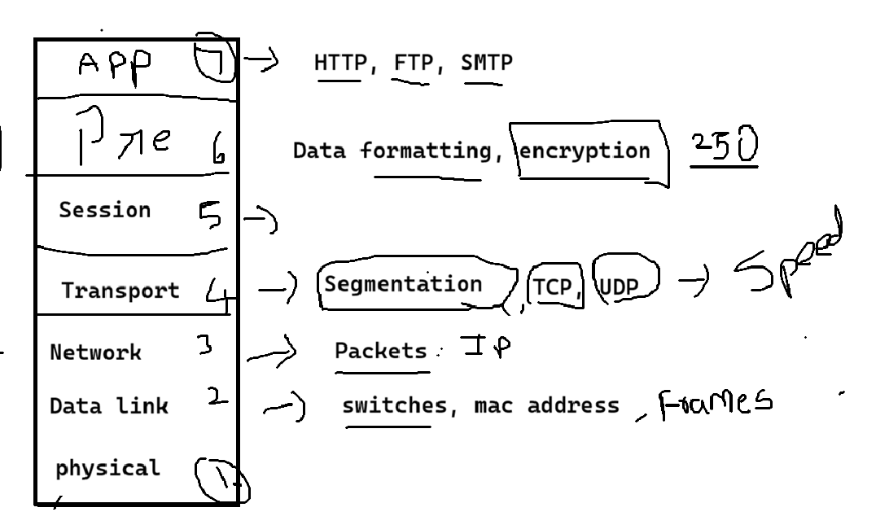

TCP/IP model => 4 layer
Application layer
Transport layer
Internet layer
Network access layer

Network communication
Unicast, => one to one
Multicast, => one to many
Broadcast => one to all

Types of address in network
IP -> internet protocol
MAC -> Physical address
DNS -> Domain name system

Get Ip from ISP -> Internet service provider

1GB => 1024 MB
1MB => 1024 KB
1KB => 1024 Bytes
1 byte = 8 bit
1 bit => 0 or 1

IP types
IPV4 -32 bit (Decimal) -> 4.3 Billion
IPV6 – 128 bit (Hexadecimal) -> unlimited

Structure of IPV4 => 4 Octet

192.168.1.0

4 octet => 32 bit
1 octet => 8 bit

Ip ranges ( 0 to 255)

157.51.20.130

0000 0000 . 0000 0000. 0000 0000. 0000 0000
128 | 64 | 32 | 16 | 8 | 4 | 2 | 1

1011 1101.0011 0011. 0001 0100. 1000 0010
172.16.9.110 =>

We have five class
Class A = 0 – 127 -> 1 – 126
Class B = 128 - 191
Class C = 192 – 223
Class D -> 224 – 239 (Multicast (many to many) )
Class E -> 240 – 255 (Research & Development)

IPV6 -> 64d4:63a8:4fb8
10 – A , 11 – B, 12 – C , 13 – D, 14 – E, 15 – F

64134: 6310: 415118

MAC address => 48 bits (Network interface card)
12 digit hexa digit

6 bit -> OUI (Organizationally unique identifier)
6 bit -> unique

NAT steps => Network address Translation
ARP - address Resolution protocol (IP to MAC)
RARP -> Reverse (MAC to IP)
Netbios -> Network basic input output system (Based on system name ) (supports only windows)
WINS -> windows internet name service (name to ip ) (non-windows family also supports)

Subnetting -> Process of splitting into multiple smaller network
Types of subnetting
Classful subnetting -> FLSM (Full length Subnet mask)
Classless subnetting -> VLSM (Variable length subnet mask)

IP class | Subnet mask | Network formula/ subnet formula | Host formula
Class A | N.H.H.H | N = (2^N)-2 | H = (2^H) -2
Class B | N.N.H.H | N = (2^N) | H = (2^H) -2
Class C | N.N.N.H | N = (2^N) | H = (2^H) -2
Class D | N.N.N.N

FLSM
192.168.1.0 (network id)
Class C

NNNH => 255.255.255.0 (Subnet mask )

Inverse mask => Network range - Subnet Mask
= 255.255.255.255 - 255.255.255.0
Inverse mask => 0.0.0.255
Ranges = Inverse mask + network Id
= 0.0.0.255 + 192.168.1.0
Ranges = 192.168.1.255 (Broadcast address)
Usable ip address => 192.168.1.1 to 192.168.1.254

H = (2^H)-2
2 ^ 8 -2
= 256 -2 => 254

172.16.0.0
10.0.0.0

VLSM -> Variable length subnet mask

172.168.0.0 Required host 100
2^7 | 2^6 | 2^5 | 2^4 | 2^3 | 2^2 | 2^1 | 2^0
128 | 64 | 32 | 16 | 8 | 4 | 2 | 1

- 128
- 192
- 224
- 240
- 248
- 252
- 254
- 255
Host = 2^H -2
= 2 ^ 7 -2 => 126
= Network bits - No of host bits
= 32 – 7
= 25 // -> Slash value(network)
= 8.8.8.1
Subnet mask = 255.255.255.128

Inverse mask = Network range – subnet mask
= 255.255.255.255 – 255.255.255.128
= 0.0.0.127
Range = inverse mask + network id
0.0.0.127 + 172.168.0.0
Range = 172.168.0.127 (Broadcast address)
Usable ip address => 172.168.0.1 to 172.168.0.126

192.168.1.0
1.Host 50
2. Host 500
3.Host 100
10.0.0.0
1. Host 70,
2.Host 250,
3.Host 20
172.16.0.0
1.Host 120
2. Host 1000
3.Host 60

CIDR -> Classless Inter-Domain Routing

192.168.0.0 / 16
10.0.0.0/8
10.0.0.0/16
17.16.1.0/25

10.0.0.0 / 8 Required subnet 4

1.Seperate the host bits and write properly
2.write a host bit place value left to right
3.Based on the requirement move a line
128 | 64 | 32 | 16 | 8 | 4 | 2 | 1
128 | 64 | 32 | 16 | 8 | 4 | 2 | 1
128 | 64 | 32 | 16 | 8 | 4 | 2 | 1
10.

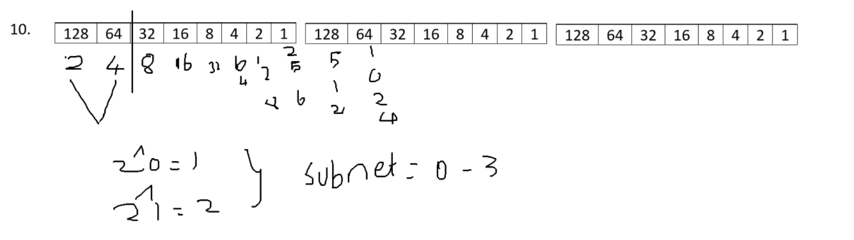

10.0.0.0 / 10
10.64.0.0 /10
10.128.0.0./10
10.192.0.0/10

20.0.0.0 / 8 Req subnet 8
128 | 64 | 32 | 16 | 8 | 4 | 2 | 1

20.

2^0 => 1
2^1 => 2
2^2 => 4
Subnet value – 0-7
20.0.0.0 / 11
20.32.0.0/11
20.64.0.0/22
20.96.0.0/11
20.128.0.0/11
20.160.0.0/11
20.192.0.0/11
20.224.0.0/11

20.0.0.0 / 8 Req subnet => 64

20.0.0.0 / 14
20.4.0.0 /14
20.8.0.0/24

